Example of completing Lab 1a – Virtualisation and Linux Setup. It covers all deliverables required, example screenshots (described in text), and reflection prompts.

Step-by-Step Solution
1. Installed VirtualBox on host OS (Windows 11). would show the VirtualBox application installed and visible in the Start Menu. 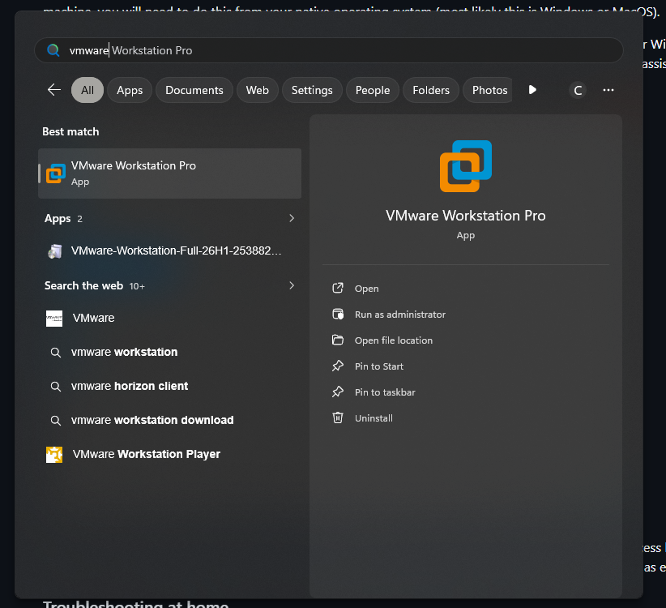
2. Downloaded Ubuntu 22.04.3 LTS ISO image from the official Ubuntu website. Screenshot would show the downloaded file (ubuntu-22.04.3-desktop-amd64.iso). 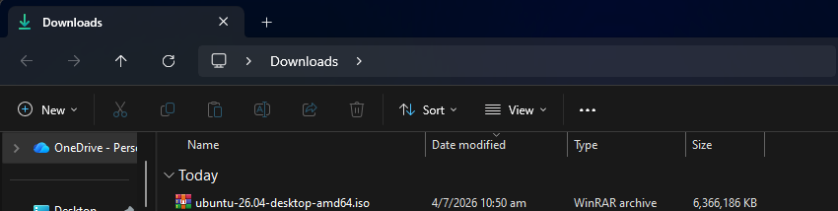

3. Created a new Virtual Machine in VirtualBox named 'Ubuntu-Lab1a' with 2048 MB RAM and 20 GB disk. Screenshot would show VM settings (RAM, boot order, ISO mounted). 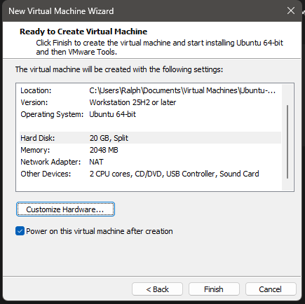
4. Booted VM using ISO and installed Ubuntu. Screenshot would show successful login screen of Ubuntu desktop.
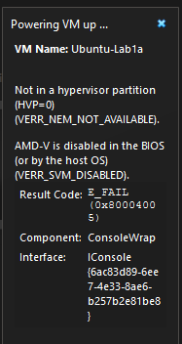
Ran into this issue when booting up VM, had to configure settings in BIOS to enable SVM 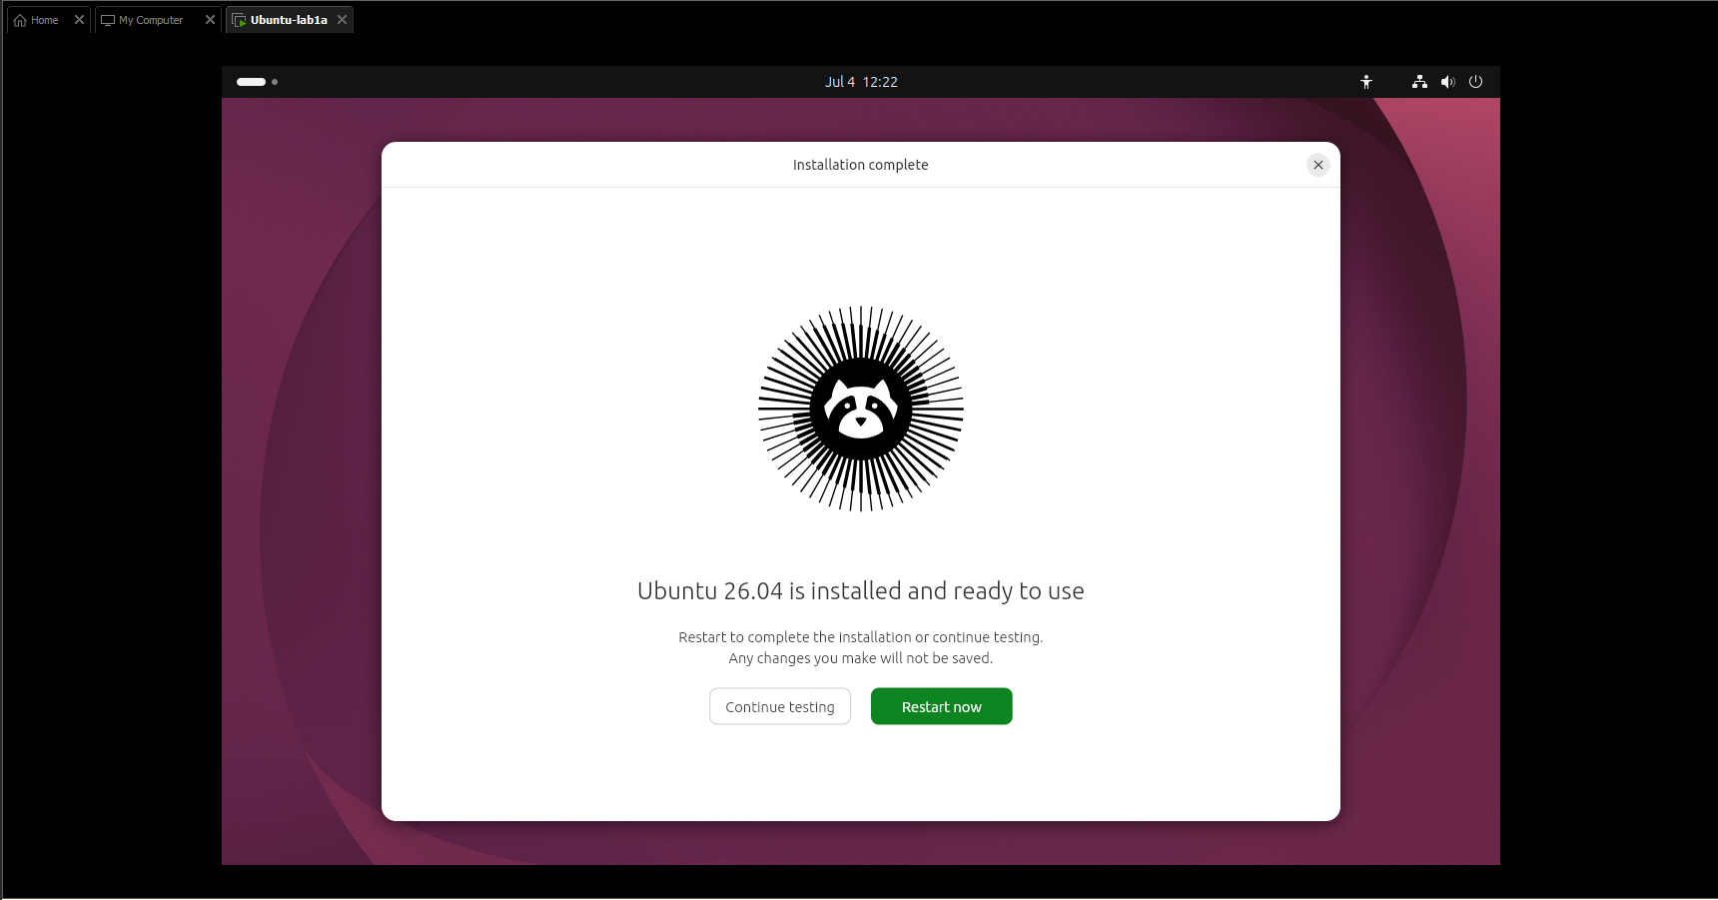
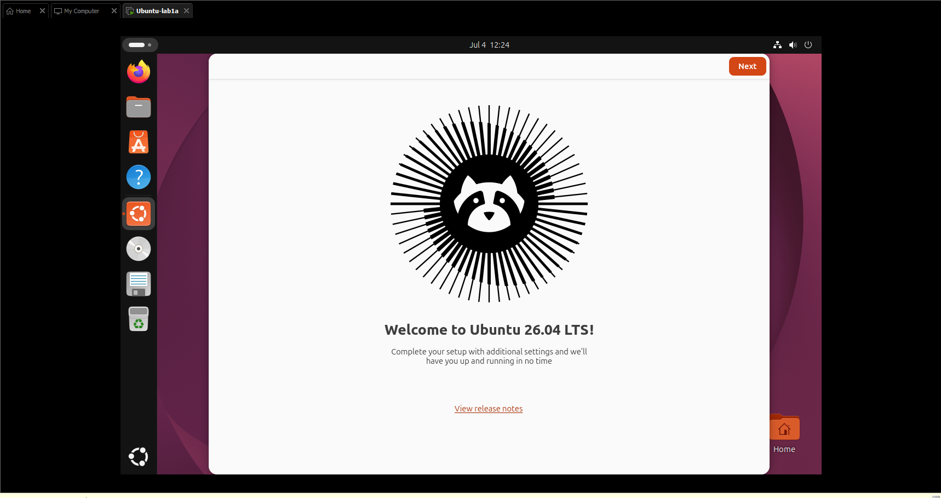
5. Configured network settings in VirtualBox using NAT mode. Screenshot would show VirtualBox Network settings page with NAT selected,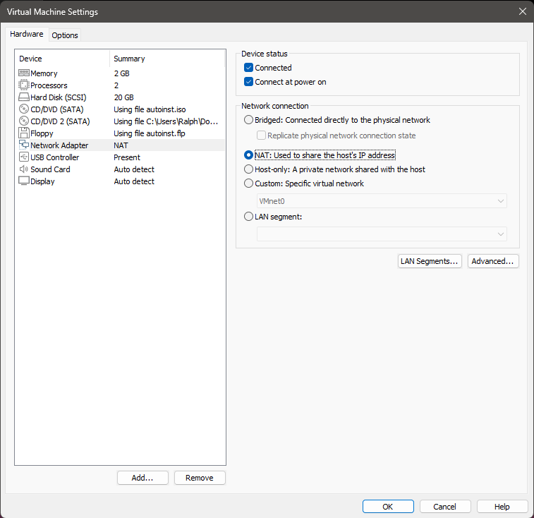

6. Verified Ubuntu running with GUI access. Screenshot would show Ubuntu desktop with Terminal open.
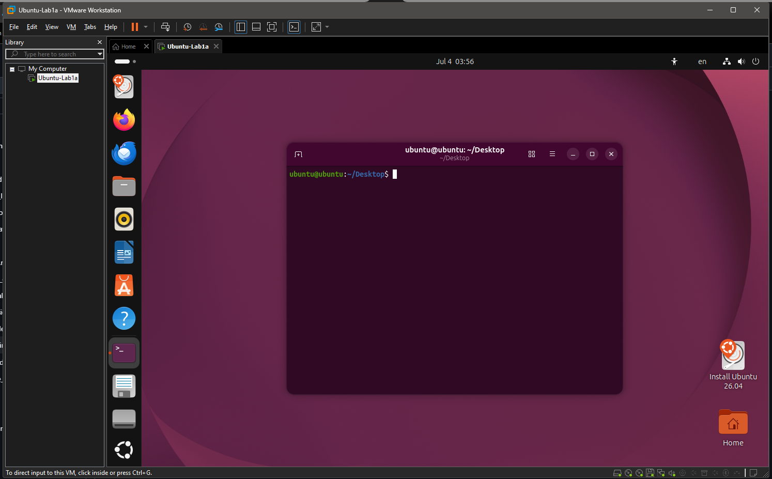
7. Installed Guest Additions inside Ubuntu. Evidence would include successful execution of `sudo apt install virtualbox-guest-utils virtualbox-guest-x11` and reboot. 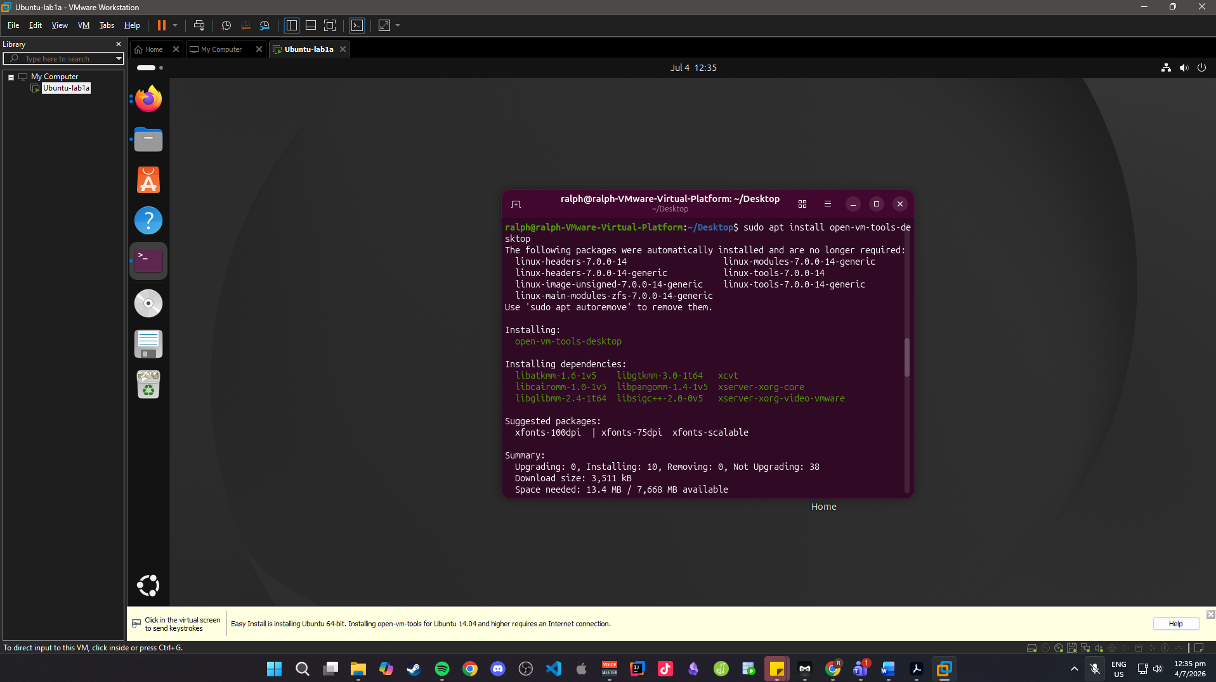
8. Enabled SSH server (advanced option). Screenshot would show `sudo apt install openssh-server` and `systemctl status ssh` confirming active service. 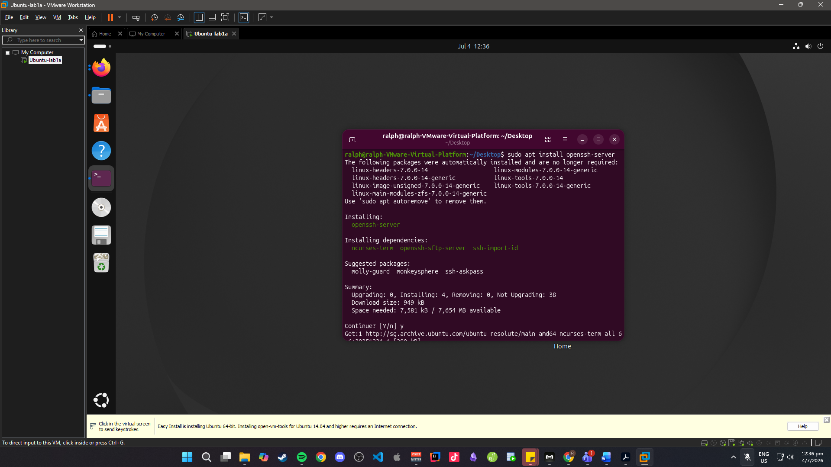
9. Alternative path: Installed WSL Ubuntu from Microsoft Store (Windows 11). Screenshot would show Ubuntu running in PowerShell with `ls` command output.
10. Bonus exploration: Installed Fedora Workstation 38 in a separate VM. Screenshot would show Fedora desktop login screen.

Deliverables
✅ VirtualBox Installed – Screenshot of installation complete.
✅ Ubuntu ISO Downloaded – Screenshot of ISO file in Downloads folder.
✅ VM Created – Screenshot of VM configuration.
✅ Ubuntu Installed – Screenshot of Ubuntu desktop/terminal.
✅ Networking Configured – Screenshot of VirtualBox NAT/Bridged settings.
✅ Ubuntu Running – Screenshot of terminal/desktop proving functionality.
✅ Guest Additions Installed – Screenshot or command output of installation.
✅ SSH Enabled – Screenshot of SSH service status.
✅ Alternate: WSL Installed – Screenshot of Ubuntu running on Windows terminal.
✅ Bonus: Other Distro Explored – Screenshot of Fedora/Kali/Debian installed.

